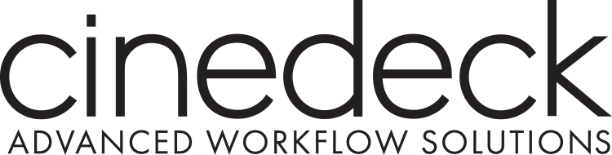

CINEDECK LAUNCHES FILE-BASED INSERT EDIT APPLICATION FOR MAC OSX
NEW YORK, NY – April 11, 2016 – Cinedeck announced cineXinsert today for Mac OSX. CineXinsert is the standalone application for Cinedeck’s patent-pending, File-based Insert Edit technology. File-based Insert Edit allows users to frame-accurately insert new segments of video, audio, or closed captioning into closed flat files, without re-exporting or re-rendering entire programs. Using cineXinsert, editors can increase their efficiency by more than 50x by eliminating the time and resource intensive processes required to re-create and QC files.
“Since the launch of File-based Insert Edit last year on our hardware platforms, we’ve seen tremendous interest from the editing community for a standalone application. We’ve addressed that resounding request by developing cineXinsert and pricing it at a level that makes it accessible to a much wider audience,” says Charles Dautremont, Cinedeck’s CTO. “Not being able to make small changes quickly and efficiently to an already exported file, is a dilemma that has confounded the post community ever since non-linear editing became widespread. CineXinsert addresses this issue without having to invest in a hardware solution.”
Like its Cinedeck hardware counterparts, CineXinsert supports a wide range of codecs including Pro Res, DNxHD, XDCAM and AVC-Intra in the most common Quick Time and MXF file wrappers. Additionally, the application is resolution independent, allowing video, audio, or closed caption inserts into files from SD to 4K and beyond. Small changes such as replacing a title or fixing an audio pop that normally would take hours, can be completed quickly and efficiently in just a few minutes. The software runs on any Mac OSX platform and allows faster than real-time inserts - The faster your hardware platform, the faster inserts are completed.
“I started using File-based Insert Edit on my shows this year and I'm a believer,” says Joe DeOliveira, Post Production Producer. “We would spend a huge amount of time watching our master delivery files, only to discover that we needed to make a minor fix. Frequently the subsequent re-encode from our NLE would have another error or glitch which required us to start over again!” says Joe. “With Cinedeck’s File-based Insert Edit, we avoid this misery and found that it's possible to complete fixes on two one hour episodes, within an hour, because we no longer need to re-encode entire shows. This is a massive improvement to our process.”
File-based Insert Edit overwrites the user-specified video or audio essence in a closed, flat file using time code in and out points, much like insert editing on tape. According to Charles Dautremont, “A lot of users and engineers ask how File-based Insert Edit works and why it took so long to achieve. I can only say, it was not easy but it’s data and like any string of 1s and 0s, it can be manipulated and programmed to work for you.”
When tape was the de facto edit and delivery standard, punching in fixes to show masters was standard procedure. It was straightforward, fast and easy. CineXinsert brings that capability to files by directly locating and frame-accurately overwriting specific video and audio essences in existing files - there is no need to re-render or re-export entire shows to incorporate changes. This also means the rest of the file is untouched so only the newly inserted frames of video, audio or closed captioning need to be reviewed or run through a QC process.
CineXinsert will debut April 16 to 21 in Las Vegas at Avid Connect and NAB (Booth SL 15413). Retailing for $1495, it will be available for purchase online at www.cineXtools.com.
About Cinedeck
Founded by cinematographers, and headquartered in New York City, USA, Cinedeck manufactures innovative recording systems for use in all video production environments. Along with on-set monitoring, playback and quality control capabilities, these recorders also unify end-to-end, camera-to-post-to-archive workflows by offering the industry’s most comprehensive range of ready-to-edit output formats. The company’s products have been adopted by hundreds of TV and cinema productions, and won TV Technology’s 2010 STAR Award, the 2010 Vidy Award, DV Magazine’s Award of Excellence, and Studio Daily’s 2012 Prime Award for Best User Interface/User Experience. The modular Cinedeck ZX directly addresses the market need for fast but cost-effective systems for broadcast and cinema production and post.
Media Contact: Jane Sung, Cinedeck, jane@cinedeck.com, (646) 747-0727

